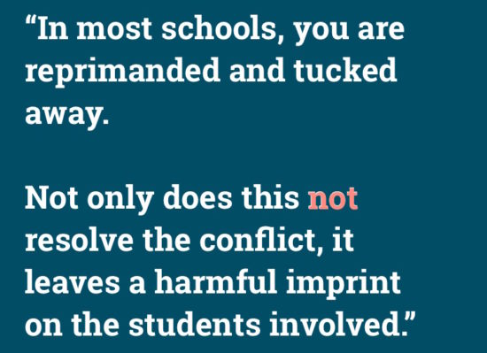Restorative Practices: What Have We learned From Our Experiences?
This Photo by Unknown Author is licensed under CC BY-NC-SA

- Start with training: find the right people to work with your school staff.
- Understand the process and the time commitment.
- Remember that Restorative Practices is not a behavior management program!
- Find the right person to lead the initiative (Director of RP?)
- Remember that this is a process that involves the community, not just the students.
- Restorative Practices helps with faculty-administrator relationships too! Adult relationships in schools often set the tone for staff-student relationships!
- Monitor the process and program, regularly and frequently.
- Assess results.
- Find other schools that will share experiences.
- Recruit teachers who are going to be willing and able to learn the process.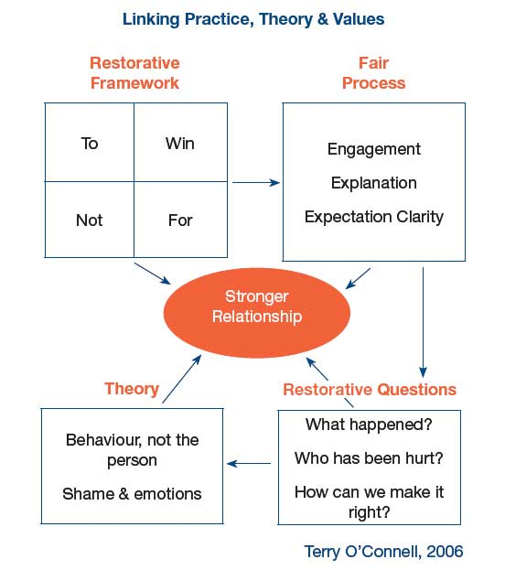
This Photo by Unknown Author is licensed under CC BY-SA

Jon McGill, 2018

